**Židovstvo, 7. razred**

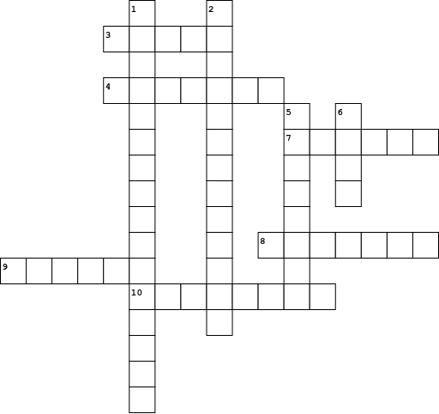

|  |  |  |  |  |  |  |  |  |  |  |  |  |  |  |  |  |  |  |  |  |  |  |  |  |  |  |
| --- | --- | --- | --- | --- | --- | --- | --- | --- | --- | --- | --- | --- | --- | --- | --- | --- | --- | --- | --- | --- | --- | --- | --- | --- | --- | --- |
| |  |  | | --- | --- | | **Vodoravno:** | | | **3.** | židovski vjerski učitelj | | **4.** | sveta knjiga Židova | | **7.** | izabrani Božji narod | | **8.** | središnja osoba židovske vjere | | **9.** | Izraelci | | **10.** | židovstvo | |  | |  |  | | --- | --- | | **Okomito:** | | | **1.** | simbol judaizma | | **2.** | neprijateljski stav prema Židovima | | **5.** | mjesto okupljanja židovskih zajednica izvan Jeruzalema radi bogoštovlja, čitanja i tumačenja Biblije | | **6.** | središnje mjesto židovskog kulta | |